# SQL Assignment - 5

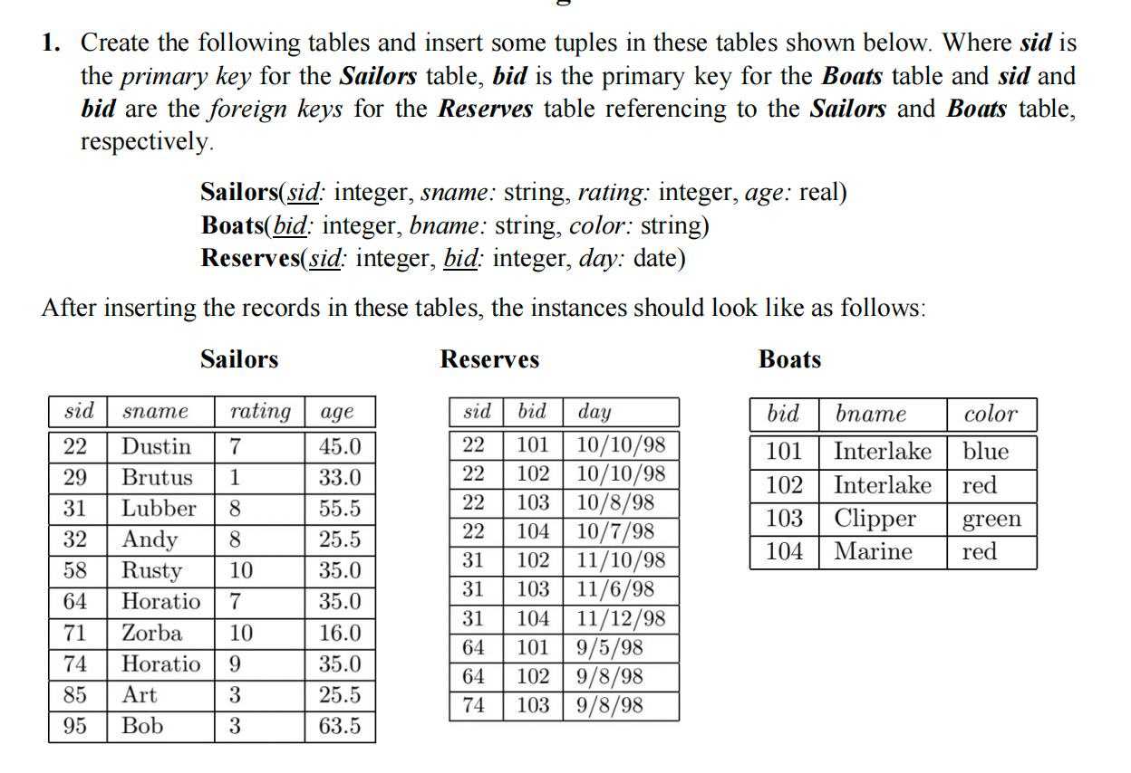

**create table Sailors(sid int primary key,sname char(25),rating int, age real);**



**describe sailors;**

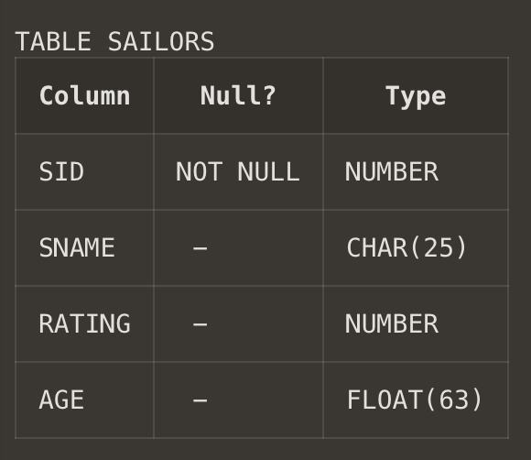

**insert into Sailors values(22,'Dustin',7,45.0);**

**insert into Sailors values(29,'Brutus',1,33.0);**

**insert into Sailors values(31,'Lubber',8,55.5);**

**insert into Sailors values(32,'Andy',8,25.5);**

**insert into Sailors values(58,'Rusty',10,35.0);**

**insert into Sailors values(64,'Horatio',7,35.0);**

**insert into Sailors values(71,'Zorba',10,16.0);**

**insert into Sailors values(74,'Horatio',9,35.0);**

**insert into Sailors values(85,'Art',3,25.5);**

**insert into Sailors values(95,'Bob',3,63.5);**

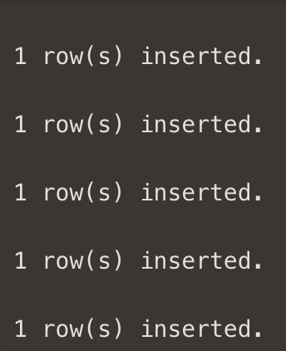 

**select * from Sailors;**

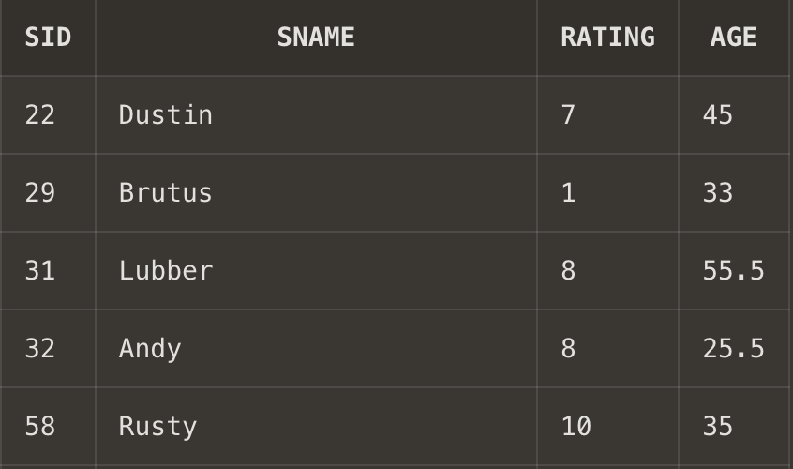

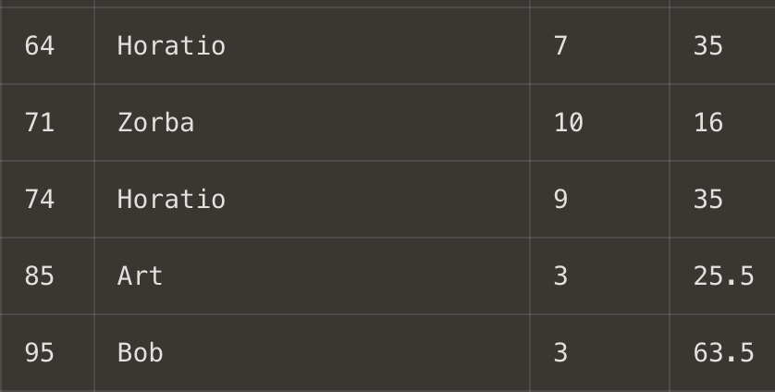

**create table Boats(bid int primary key,bname char(25),color char(25));**



**describe Boats;**

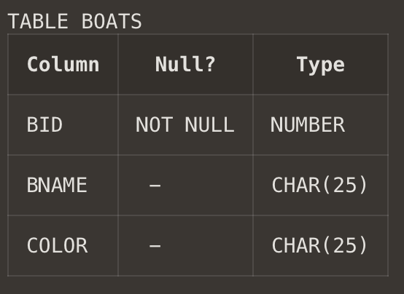

**insert into Boats values(101,'Interlake','blue');**

**insert into Boats values(102,'Interlake','red');**

**insert into Boats values(103,'Clipper','green');**

**insert into Boats values(104,'Marine','red');**

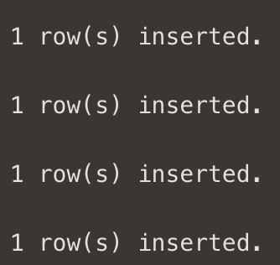

**select * from Boats;**

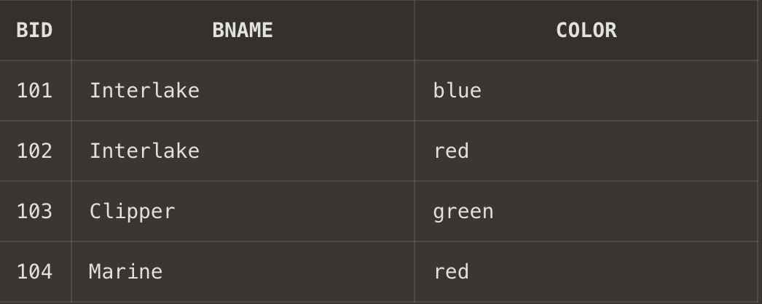

**create table Reserves(sid int,bid int , day date, constraints FK_Res1 foreign key (sid) references Sailors(sid),constraints FK_Res2 foreign key (bid) references Boats(bid));**



**describe Reserves;**

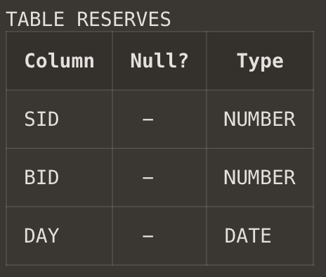

**insert into Reserves values(22,101,'10-OCT-1998');**

**insert into Reserves values(22,102,'10-OCT-1998');**

**insert into Reserves values(22,103,'10-AUG-1998');**

**insert into Reserves values(22,104,'10-JUL-1998');**

**insert into Reserves values(31,102,'11-OCT-1998');**

**insert into Reserves values(31,103,'11-JUN-1998');**

**insert into Reserves values(31,104,'11-DEC-1998');**

**insert into Reserves values(64,101,'09-MAY-1998');**

**insert into Reserves values(64,102,'09-AUG-1998');**

**insert into Reserves values(74,103,'09-AUG-1998');**

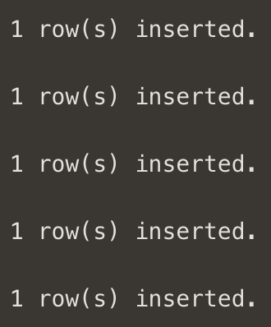 

**select * from Reserves;**

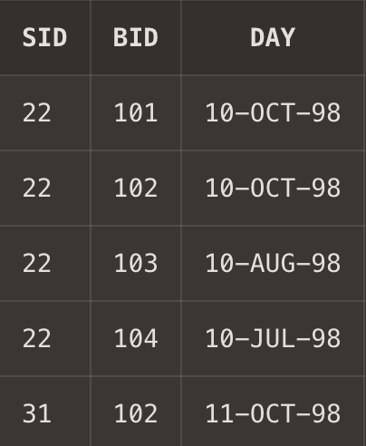

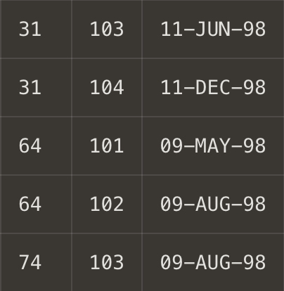

1. **Write SQL commands for the following.**
2. **Show the names and ages of all sailors.**

**Ans1. select sname,age from Sailors;**

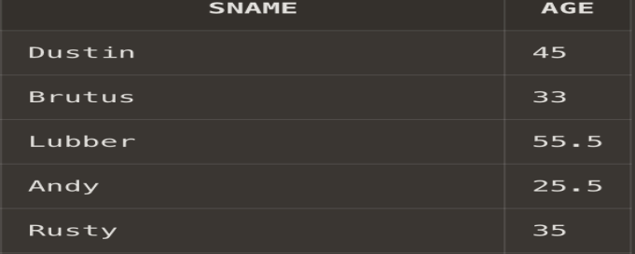

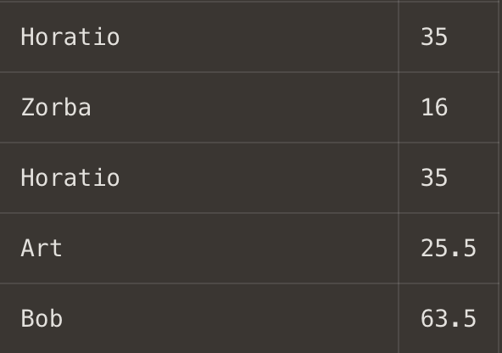

1. **Show details of the boats which are red and blue in color.**

**Ans2. select * from Boats where color='blue' or color='red';**

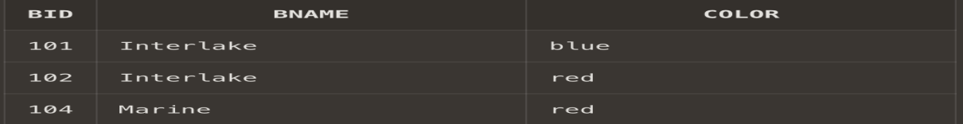

1. **Find the oldest and youngest sailors’ age.**

**Ans3. select max(age) as Oldest_Sailor,min(age) as Yongest_sailor from sailors;**

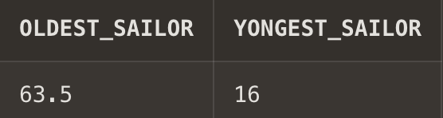

1. **Find the ages of sailors whose name begins and ends with B and has at leastthree characters.**

**Ans4. select age from Sailors where (sname like 'B_%b' or sname like 'B_%B' or sname like 'b_%b' or sname like 'b_%B') ;**

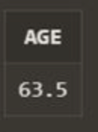

1. **Show the average rating of the sailors.**

**Ans5. select avg(rating) from Sailors;**

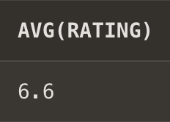

1. **Find all sailors with a rating above 7.**

**Ans6. select * from sailors where rating>7;**

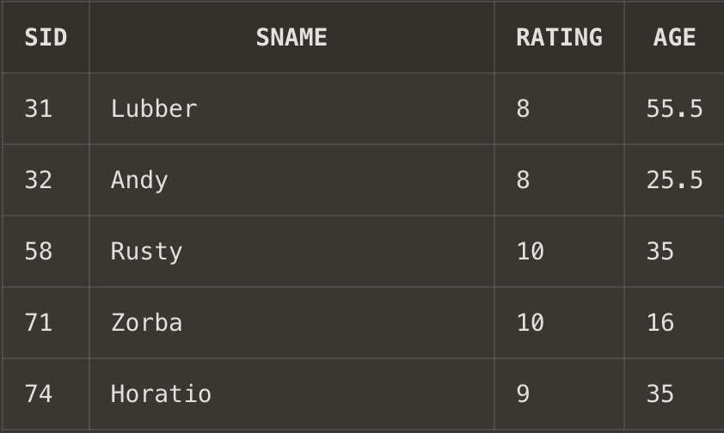

1. **Find the number of boats reserved by the sailor named Horatio.**

**Ans7. select count(*) from sailors,reserves where sailors.sid=reserves.sid and sailors.sname='Horatio';**

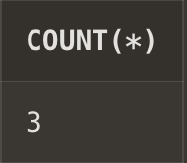

1. **Find the colors of boats reserved by Lubber.**

**Ans8. select color from boats,Sailors,Reserves where Sailors.sname='Lubber' and Sailors.sid=Reserves.sid and reserves.bid=boats.bid;**

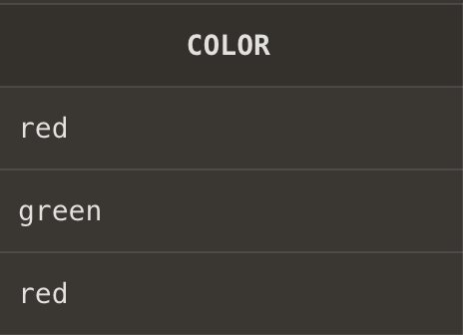

1. **Show the details of the sailors who have reserved the boat with bid 102.**

**Ans9. select sailors.sid,sname,rating,age from sailors,reserves where sailors.sid=reserves.sid and reserves.bid=102;**

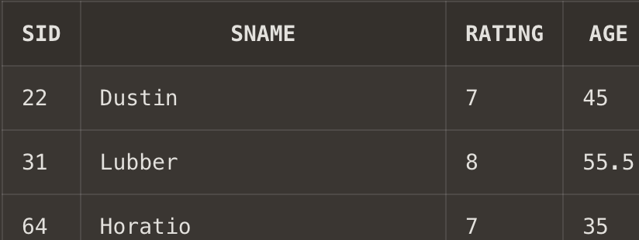

1. **Find the sid of sailors who have reserved green boats**

**Ans10. select sid from Reserves ,boats where Boats.color='green' and Boats.bid=Reserves.bid;**

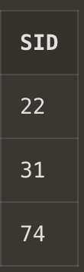

1. **Find the names of sailors who have reserved boat number 103.**

**Ans11. select sname from sailors,boats,reserves where boats.bid=103 and Boats.bid=Reserves.bid and Reserves.sid=Sailors.sid;**

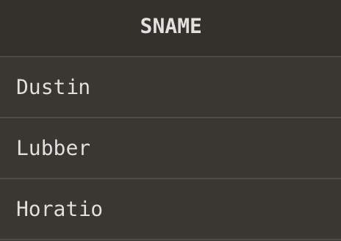

1. **Find the sids and names of sailors who have reserved a red boat.**

**Ans12. select distinct sailors.sid,sname from sailors,boats,reserves where sailors.sid=reserves.sid and reserves.bid=boats.bid and boats.color='red';**

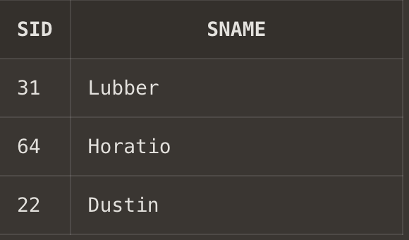

1. **Find the names of all the sailors who have reserved a green or a blue boat.**

**Ans13. select distinct sailors.sname from sailors,boats,reserves where sailors.sid=reserves.sid and reserves.bid=boats.bid and (boats.color='blue' or boats.color='green');**

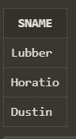

1. **Find the names of sailors who have reserved both a red and a green boat.**

**Ans14. select distinct sailors.sname from sailors,boats,reserves where sailors.sid=reserves.sid and reserves.bid=boats.bid and (boats.color in('red','green'));**

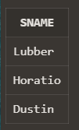

1. **Find the names of sailors who have reserved at least one boat.**

**Ans15. select distinct sailors.sname from sailors,reserves where sailors.sid=reserves.sid;**

